FORMULATION AND IN-VITRO EVALUATION OF FESOTERODINE FUMARATE LOADED MICROBEADS by ION GELATION METHOD

Thesis submitted to
FACULTY OF PHARMACY

OSMANIA UNIVERSITY, HYDERABAD-500007

by

G. SATHVIKA | 170419881021
P. DIVYA JYOTHI | 170419881059
S. CHERISHMA | 170419881066
S. SAISNEHANJALI | 170419881067

In partial fulfillment of the award of the degree of
BACHELOR OF PHARMACY
IN
PHARMACEUTICS

Under the Guidance of
Smt. G. SRI LALITHA, M. Pharm, (Ph.D)
Assistant Professor, Department of Pharmaceutics


SAROJINI NAIDU VANITA PHARMACY MAHA VIDYALAYA
Tarnaka, Hyderabad - 2023

Declaration

We hereby declare that the project work entitled “Formulation and In-vitro Evaluation of Fesoterodine Fumarate Loaded Microbeads by Ion Gelation Method” is based on the original work carried out by us under the supervision of Smt. G. SRI LALITHA at SAROJINI NAIDU VANITA PHARMACY MAHA VIDYALAYA, Tarnaka, Hyderabad. We also affirm that this work is original and has not been submitted in part or full, for any other degree or diploma to this or any other University or Institution.

Date:

G. SATHVIKA | 170419881021
P. DIVYA JYOTHI | 170419881059
S. CHERISHMA | 170419881066
S. SAISNEHANJALI | 170419881067

CERTIFICATE

This is to certify that the project work entitled “Formulation and In-vitro Evaluation of Fesoterodine Fumarate Loaded Microbeads by Ion Gelation Method” is a work carried out by G. Sathvika, P. Divya Jyothi, S. Cherishma, S. Saisnehanjali under my supervision at SAROJINI NAIDU VANITA PHARMACY MAHA VIDYALAYA and submitted to OSMANIA UNIVERSITY, Hyderabad for the partial fulfillment of the award of the degree of “BACHELOR OF PHARMACY”. This work is original and has not been submitted earlier to this or any other university either in part or full for the award of any degree or diploma.

Date:

Smt. G. Sri Lalitha
(Assistant professor)
Department of Pharmaceutics.

CERTIFICATE

The project work entitled, “Formulation and In-vitro Evaluation of Fesoterodine Fumarate Loaded Microbeads by Ion Gelation Method” is a bonafide work carried out by G. Sathvika, P. Divya Jyothi, S. Cherishma, S. Saisnehanjali under the supervision of Smt. G. Sri Lalitha at SAROJINI NAIDU VANITA PHARMACY MAHA VIDYALAYA and submitted to OSMANIA UNIVERSITY, Hyderabad for the partial fulfillment of the award of the degree of “BACHELOR OF PHARMACY”. This work is original and has not been submitted earlier to this or any other university either in part or full for the award of any degree or diploma.

Date:

Dr. T. Saritha Jyostna.

Principal, SNVPMV

ACKNOWLEDGEMENTS

It gives me an immense pleasure and pride to express our deep sense of gratitude and respect for our teacher and guide, Smt. G. Sri Lalitha, SNVPMV, Hyderabad, for her evergreen expertise and inspiring guidance throughout the period of my work. She is the one behind giving me a decisive turn and a significant boost to my career.
I express our deep sense of gratitude to Dr. B. Prabha Shankar, Chairman -SNVPMV, Dr. N. Srinivas, Director – SNVPMV, Dr. T. Saritha Jyostna, Principal - SNVPMV Dr. T. Mamatha, Vice-Principal – SNVPMV. for permitting me and providing all the necessary support and facility in SNVPMV Hyderabad.
My sincere gratitude to all the faculty of SNVPMV for their valuable suggestions and timely support through-out the work.
I would like to extend my gratitude to technical and other supporting staff members of SNVPMV, for their support and help whenever we needed.
I would like to thank my friends and all who has directly or indirectly helped me during my project.
I take pleasure to express my sincere thanks to SNVPMV, sponsored by Exhibition society, Hyderabad for providing financial support.
My list would certainly not be completed without a special thanks to my parents and my family members for their grace, support and guidance.
Name of the students
G. Sathvika
P. Divya Jyothi
S. Cherishma
S. Saisnehanjali

S.NO | LIST OF CONTENT | PAGE NO
 | INTRODUCTION
 | LITERATURE REVIEW
 | AIM AND OBJECTIVE
 | PLAN OF WORK
 | DRUG PROFILE
 | EXCIPIENT PROFILES
 | METHODOLOGY
 | EVALUATION
 | RESULTS AND DISCUSSION
 | CONCLUSION
 | BIBLIOGRAPHY

S.NO | LIST OF TABLES | PAGE NO
1 | Cross-linking agents used for the preparation of alginate gel
2 | Experimental properties of Fesoterodine Fumarate
3 | Interaction with other drugs
4 | Composition of different microbeads containing Fesoterodine Fumarate
5 | List of materials /ingredients used
6 | List of equipment used
7 | Organoleptic properties
8 | Calibration curve of Fesoterodine Fumarate in ph 6.8 phosphate buffer
9 | Evaluation parameters
10 | FTIR spectra of Fesoterodine Fumarate pure drug display principal bands at a wave number as follows.
11 | In-vitro dissolution studies of different formulations (F1-F4)
12 | In-vitro dissolution studies of different formulations (F5-F8)

S.NO | LIST OF FIGURES | PAGE NO
1 | plasma Concentration vs Time Profile
2 | Sodium Alginate Beads
3 | Drug Release from Beads in different ways
4 | Dropping Method for Preparation of Alginate Beads
5 | Microbeads Prepared by Emulsification Methods
6 | Sodium Alginate Beads by Ionotropic Gelation Method
7 | Preparation of Microbeads by using Syringe Needle
8 | Drying of Microbeads and Packing
9 | Standard Graph of Fesoterodine Fumarate
10 | FTIR spectrum of Calcium Chloride
11 | FTIR spectrum of Sodium Alginate
12 | FTIR spectrum of HPMC
13 | FTIR spectrum of Fesoterodine Fumarate
14 | In-vitro Drug release (F1-F4)
15 | In-vitro Drug release (F5-F8)

LIST OF ABBREVIATION

S.NO | ABBREVIATION | EXPANDED TERMINOLOGY
1 | OBD | overactive bladder disease
2 | API | active pharmaceutical ingredient
3 | nm | Nanometer
4 | µm | Microgram
5 | pH | Negative logarithm of hydrogen ion concentration
6 | ml | Milliliters
7 | FTIR | Fourier transform infrared spectroscopy
8 | IUPAC | International Union of pure and applied chemistry
9 | USP | United states pharmacopeia
10 | hrs | Hours
11 | µm/ml | Microgram per millilitre
12 | mg | Milligrams
13 | gm | Grams
14 | min | Minutes
15 | rpm | Rotations per minute
16 | UV | Ultraviolet spectroscopy
17 | HPMC | Hydroxypropyl Methylcellulose
18 | 5-HMT | 5-hydroxymethyl tolterodine
19 | R² | Regression Coefficient

ABSTRACT

The aim of the project is to Formulation and In-Vitro Evaluation Of Fesoterodine Fumarate Loaded Microbeads by Ion Gelation Method to facilitate sustained release action to treat Overactive Bladder Disease (OBD). The gel beads were made by gently combining or homogenizing an oil and water phase containing sodium alginate, which was then extruded into a calcium chloride solution to create gel beads. The gel beads contained various amounts of egg albumin, HPMC, and tween-80.The effects of types of egg albumin, HPMC, and their proportions, on the morphology and release characteristics, were optimized. At different proportions of polymers were used to study the effect on the sustaining property of the formed beads. The drug-entrapped sodium alginate gel beads showed sustained release. Among different formulations, the combination of HPMC, egg albumin, and sodium alginate with different concentrations of and have 98% of drug release and F4 considered as optimized formulation.

INTRODUCTION

With many drugs, the basic goal of therapy is to achieve a steady state blood or tissue level that is therapeutically effective and nontoxic for an extended period of time. The design of a proper dosage regimen is an important element in accomplishing this goal. A basic objective in dosage form design is to optimize the delivery of medication so as to achieve a measure of control for the therapeutic effect in the face of uncertain fluctuations in the in vivo environment where the drug release takes place. This is usually accomplished by maximizing drug availability, i.e., by attempting to attain a maximum rate and extent of drug absorption, however, control of drug release through formulation also implies controlling bioavailability to reduce drug absorption rates.^{[1]}
Sustained release (SR) systems are defined as “Any drug delivery system that achieves slow release of drug over an extended period of time if this system provides some control as spatial, temporal or both for drug releases in the body and it is considered as a sustained release system”.

THE SUSTAINED RELEASE CONCEPT
Sustained release, sustained action, prolonged action, controlled release, extended action, timed release, depot, and repository dosage forms are terms used to identify drug delivery systems that are designed to achieve a prolonged therapeutic effect by continuously releasing medication over an extended period of time after administration of a single dose. In the case of orally administered forms, however, this period is measured in hours and critically depends on the residence time of the dosage form in the gastrointestinal tract.
The goal in designing a sustained or controlled delivery system is to reduce the frequency of dosing or to increase the effectiveness of the drug by localization at the site action, reducing the dose required, or providing uniform drug delivery.
If one were to imagine the ideal drug delivery system, two prerequisites would be required. First, it would be a single dose for the duration of treatment, whether it is for days or weeks, as in infections, or for a lifetime of the patient, as in hypertension or diabetes. Second, it should deliver the active entity (drug) directly to the site of action, thereby minimizing or eliminating side effects. This may necessitate delivery to specific receptors or to localization to cells or to specific areas of the body.^{[2]}
It is obvious that this imaginary delivery system will have changing requirements for different disease states and different drugs. Thus, we wish to deliver the therapeutic agent to a specific site and for a specific time. In other words, the objective is to achieve both spatial and temporal placement of the drug. Currently, it is possible to only achieve both of these goals, with most drug delivery system. ^{[3]}

Fig No 1: Plasma Concentration Vs Time Profile
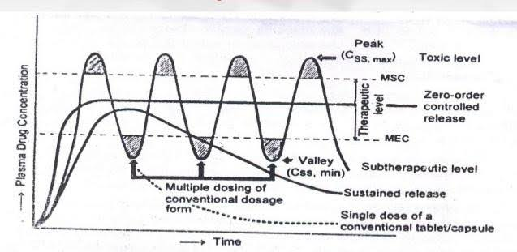
ADVANTAGES OF SUSTAINED RELEASE DOSAGE FORM
- The frequency of drug administration will be reduced.
- Patient compliance can be improved.
- Drug administration can be made more convenient as well.
- The blood level oscillation characteristic of multiple dosing of conventional dosage forms is reduced because a more even blood level is maintained.
- The total amount of the drug administered can be reduced, thus maximizing availability with a minimum.
- Better control of drug absorption can be attained by reducing availability.
- The safety margin of high-potency drugs can be increased, and the incidence of both local and systemic adverse side effects can be reduced.
- Overall, the administration of sustained release forms enables increased reliability of therapy. ^{[4,5]}
DISADVANTAGES OF SUSTAINED RELEASE DOSAGE FORM
- Administration of sustained-release medication does not permit the prompt termination of therapy. Immediate changes in drug need during therapy, such as might be encountered if significant adverse effects are noted, cannot be accommodated.
- The physician has less flexibility in adjusting dosage regimens. This is fixed by the dosage form design.
- Sustained release forms are designed for the normal population, i.e., on the basis of average biological half-lives. Consequently, disease states that alter drug disposition, significant variation, and so forth are not accommodated.
- Economic factors must also be assessed since more costly processes and equipment are involved in the manufacturing of many sustained-release dosage forms. ^{[4,5]}

MICROBEADS
The release of a drug from a micro-particle depends on a variety of factors, including the carrier used to form the microparticle and the amount of drug contained in it.^{[6]} Beads are one of the most commonly used techniques in a sustained-release dosage form. These are spherical particles with a size ranging from 50 nm to 2 mm, which contain core substances. The molecular size of the drug particle must be less than 1000 Dalton to formulate as SRDF.^{[7]} Many APIs show problems like low biological availability and repeated dosing due to poor solubility and penetration through lipid membranes. ^{[8]} Among them, oral API administration is the most routine way to take medicines. Because of their short t1/2 and less absorption through a part of the small intestine, it restricts the use of many APIs. This gives an effect on pharmacokinetic activity which causes frequent dosing of many APIs to achieve their effective dose. This causes pill burden and poor patient compliance.^{[9]}
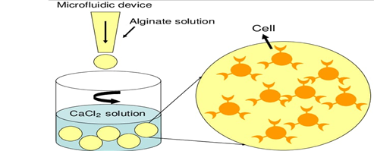

Fig No 2: Sodium Alginate Beads
The Particulate API delivery system is one of the approaches to improving the physicochemical properties of API. The particulate API delivery system depends on altering the physical character of the API to alter its characteristics like solubility, permeability, etc. Among the many applications of the particulate system, mucoadhesive activity is important, where API release can be controlled and designed by using repeating units of natural substances such as poliglusam, sodium alginate, and so on. The overall action of API can be controlled by the active ingredients, which have a short t1/2 of fewer than 4 hours, which is the main reason for frequent dosing or multiple dosing of medication when using the particulate system of API delivery. The delivery system includes many pellets, beads, lipospheres, microspheres, microcapsules, etc. The various substances (polymers) used as carriers in the microsphere are chitosan, sodium alginate, gum ghatti Hpmc k100m, etc.^{[10]}
The sustained release system was designed to release slowly over some time a drug in the body (organs or tissues). It is a system that delivers a drug to a specific target in the body with a delay after its administration. Drugs that are easily absorbable in the gastrointestinal tract and have short t1/2 will be eliminated quickly from the blood circulation, so they require frequent dosing to control this drawback. The sustained release formulation had been developed to maintain the drug concentration level. And to maintain the effective concentration in the blood for a longer period, in the sustained release dosage form, the drug is released over a sustained period but should not at a constant rate, whereas in the controlled release dosage form which maintains the drug release over a sustained period at a constant rate. Beads are spherical particles that range in size from 50 nm to 2 mm and contain core substances. The sustained-release beads are the spherical substances that contain the active pharmaceutical ingredient and are designed to release the drug at a predetermined rate at a constant concentration in the body. These beads were used for the modified release of medications, antibiotics, hormones, and vaccines. The oral sustained-release beads are polymer-coated.^{[11]}

Table No. 1: Cross-linking agents used for the preparation of alginate gel
S. No. | Cross-linking agent | Properties
A) Organic
1)  2)  3) | Epichlorohydrin  N, N-(3-Dimethyl - aminopropyl)-Nethylcarbodi- imide (EDC)  Glutaraldehyde | Beads produced are reported to be more elastic than calcium alginate beads. Also after drying and the subsequent reswelling, their pore size and dimensions remain the same.  Improvement observes in the mechanical properties.  Enhances mechanical stability but not is recommended due to its toxicity
B) Inorganic
1)  2)  3) | Ca++  Al++  Zn++ | The most widely used cross-linking agent leads to the production of calcium alginate gel. Beads obtained are compact, but the pore dimensions and volume change after drying and subsequent reswelling widely used cross-linking agent leads to the production of calcium alginate gel. obtained Beads are compact, but the pore dimensions and volume change after drying and subsequent reswelling.  Affects the release profile as well as the morphology of beads.  Release slowly as compared to calcium beads

ADVANTAGES
- Ideal pharmacokinetic properties
- Enhance homogenous deviation in the body
- Minimum dose variation in the combinations of API & less dose-dumping; separate the protect the active ingredients to give better compatibility
- The new system with an increased duration of action
- Decrease dosing frequency
- Improve patient compliance
- Reducing side effects
DISADVANTAGES
- Compared to another formulation cost of this system is much higher.
- The use of synthetic polymer gives it an impact on the environment.
- The other component of the system plays a hazardous role in certain areas of human life.
- Reproducibility of preparation is minimal.
- The degradation substance of the repeating unit is produced.

PROPERTIES OF ALGINATES:
Solubility: Sodium alginates are slowly soluble in cold water, forming a viscous, colloidal solution. It is insoluble in alcohol and hydroalcoholic solutions in which alcohol content is greater than 30% by weight. It is also insoluble in other organic solvents such as chloroform and ether, as well as acids where the resulting solution's pH falls below 3.0.
Viscosity: Different grades of sodium alginates are available, resulting in aqueous solutions with viscosities ranging from 20 to 400 centipoises (0.02-0.4 PaS) in 1% solution at 200°C. Due to its distribution of chain lengths, alginate solutions are not Newtonian and behave as a pseudoplastic fluid.
Degradation and Chemical stability: Degradation of a Ca 2+ cross-linked alginate gel can occur by the removal of the Ca2+ ions. This can be accomplished by the use of a chelating agent such as ethylene glycol-bis (b-aminoethyl ether)-N, N, N’, N’-tetra acetic acid (EGTA), citrate, lactate, and phosphate or by a high concentration of ions such as Na+ or Mg2+. As Ca2+ ions remove the cross-linking in the gel decreased and the gels are destabilized.
Sterilization: Filtration is the simplest and least detrimental means of aseptization but mostly alginate solutions are sterilized by autoclaving rather than filtration.
Immunogenicity and Biocompatibility: Biocompatibility and immunogenicity of polymer materials
are two cardinal issues for successful application in carriers for drug delivery. The chemical composition and mitogenic contaminants found in alginates, according to most authors, are two major contributors to alginate Immunogenicity.

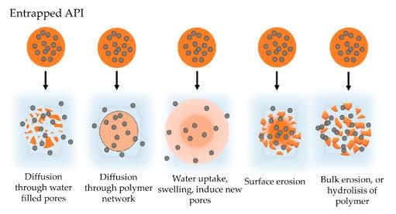
Bioadhesion: Bioadhesion was generally defined as the adhesion or contact between two surfaces with one being a biological substratum. If one of the surfaces involved is a mucosal layer, the term mucoadhesion is used. Alginate possesses a bioadhesive property that can serve as a potential advantage in mucosal drug delivery. ^{[22,23]}

Fig No 3: Drug Release from Beads in Different Ways

Overactive Bladder Disease (OBD) is a common condition where there is a frequent feeling of needing to urinate to a degree that negatively affects a person's life. The frequent need to urinate may occur during the day, at night, or both. If there is a loss of bladder control then it is known as urge incontinence. Overactive bladder affects approximately 11% of the population and more than 40% of people with overactive bladder have incontinence. Conversely, about 40% to 70% of urinary incontinence is due to an overactive bladder. Overactive bladder is not life-threatening, but most people with the condition have problems for years.
The cause of an overactive bladder is unknown. Risk factors include obesity, caffeine, and constipation. Poorly controlled diabetes, poor functional mobility, and chronic pelvic pain may worsen the symptoms. People often have the symptoms for a long time before seeking treatment and the condition is sometimes identified by caregivers. Diagnosis is based on a person's signs and symptoms and requires other problems such as urinary tract infections or neurological conditions to be excluded. The amount of urine passed during each urination is relatively small. Pain while urinating suggests that there is a problem other than an overactive bladder.
Specific treatment is not always required. If treatment is desired pelvic floor exercises, bladder training, and other behavioral methods are initially recommended. Weight loss in those who are overweight, decreasing caffeine consumption, and drinking moderate fluids, can also have benefits. Medications, typically of the anti-muscarinic type, are only recommended if other measures are not effective. They are no more effective than behavioral methods; however, they are associated with side effects, particularly in older people. Some non-invasive electrical stimulation methods appear effective while they are in use. Injections of botulinum toxin into the bladder is another option. Urinary catheters or surgery are generally not recommended. A diary to track problems can help determine whether treatments are working.
Overactive bladder is estimated to occur in 7–27% of men and 9–43% of women. It becomes more common with age. Some studies suggest that the condition is more common in women, especially when associated with loss of bladder control. Economic costs of the overactive bladder were estimated in the United States at US$12.6 billion and 4.2 billion Euro in 2000.

FESOTERODINE FUMARATE ON OBD
Muscarinic receptors have long been the target receptors for treatment of patients with overactive bladder (OBD). These patients experience symptoms of urgency, urinary frequency and nocturia, with or without urge incontinence (the involuntary leakage of urine associated with urge). Fesoterodine, a pro-drug, structurally and functionally related to tolterodine, is the newest agent developed for the treatment of OBD. Fesoterodine is broken down to the active metabolite, 5-hydroxy-methyl-tolterodine (5-HMT) by non-specific esterases. This metabolism results in the complete breakdown of the parent compound and is responsible for dose-related improvements in clinical efficacy and health-related quality of life. Like other antimuscarinic agents including tolterodine, fesoterodine is associated with improvements in clinical variables related both to bladder filling (decreasing micturition frequency and increasing mean voided volume) and urgency (urgency and urge incontinence episodes). Improvements in health-related quality of life following treatment with fesoterodine is indicated by improvements in 7 of the 9 variables measured by the King’s Health Questionnaire. Also, like other antimuscarinic agents, fesoterodine use is associated with adverse events including dry mouth. However, the incidence of dry mouth is reduced with fesoterodine, compared to oxybutynin, due to the improved bladder selectivity of 5-HMT.

METHODS OF PREPARATION OF ALGINATE BEADS:
The methods for the preparation of alginate beads or microparticles should be such that they allow for the production of beads with narrow size distribution and has a high production rate. Alginate beads are conventionally prepared by extrusion through needles into calcium solutions. Air-jet, electrical potential, vibration units, etc. have been added to increase the droplet output of syringe-based systems.
Air atomization:
Requires an extrusion device with a small orifice through which alginate solutions containing the drug are forced. Beads are 5 to 200 µm particles that can be produced. The size of beads could be controlled by either adjusting gas and liquid flow and operating pressure or the distance between the orifice and the surface of the crosslinking solution.^{[25]}
Coaxial bead generator:
Coaxial airstream pulls as droplets from a needle tip into a gelling bath. It can produce spherical beads are ranging in size down to around 400 µm.
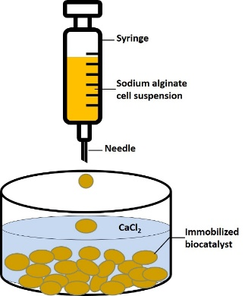
Dropping method: It is a simple method. The use of a syringe with a needle or a pipette is required. It is the most extensively utilized method for preparing the > 500 µm particles. The size of the beads formed is dependent on the size of the needle used and the viscosity of the alginate solution.^{[26]}
Fig No 4: Dropping Method for Preparation of Alginate Beads

Electrostatic bead generator:
The electrostatic force pulls droplets from the needle tip into a gelling bath. This method can generate particles ranging from 150 to 1000 m in size. Bead size depends upon the voltage and distance between the needle tip and the gelling bath, solution viscosity, flow rate of the solution as well as on needle diameter.
Emulsification:
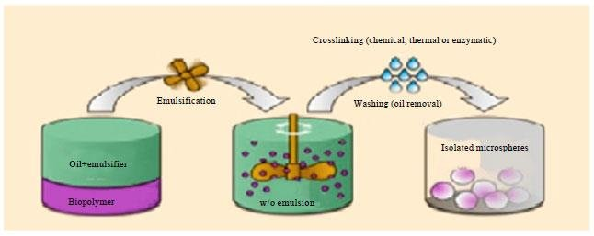
Used only for stable drugs because it involves the use of harsh chemical reagents to remove oil at the end of the process. Particles with sizes ranging from 1 to 150 m could be created by this method. The size of microbeads produced depends upon stirring speed and the rate of the addition of the this-linking solution.
Fig No 5: Microbeads prepared by Emulsification Methods

Laminar jet breaks up technique:
A device depends on a laminar jet break up induced by applying a sinusoidal frequency with the defined amplitude to the nozzle. Normally, 300 to 600 mm particles have been produced.
Mechanical cutting:
Bead formation was accomplished using a rotating cutting tool that cuts the jet into uniform cylindrical segments that form spherical beads due to surface tension as they fall into a gelling bath. 150 µm to 3 mm particles can be produced.
Spinning disk atomization:
Bead formation was achieved by a specially designed spinning disk atomizer. These are suitable for 300 to 600 µm size particles.
Vibrating nozzle technique:
This encapsulation technique is based on the harmonically vibrating nozzle. More than 200 m particles can be produced using this method.^{[27]}
Complex coacervation:
Under specific conditions of polyion concentration, pH, and ionic strength, the polyelectrolyte mixture could separate into two distinct phases; a dense coacervate phase which can contain the microbeads, and a dilute equilibrium phase. Oppositely charged complex poly-electrolytes had been commonly used. The optimal conditions for the maximum coacervate yield are a pH of 3.9, ionic strength of 1 mM, and a total polyion concentration of 0.15% w/v.^{[28]}

SODIUM ALGINATE BEADS ARE COMMONLY PREPARED USING THE FOLLOWING METHODS:
Ionotropic Gelation Method
For bead formation, 50 mL of a 2-2.5 % w/v aqueous solution of sodium alginate was added dropwise from a glass syringe with a size-22G needle into 100 mL of an aqueous calcium chloride solution being stirred at 400 rpm. The concentration of CaCl2 in the solution ranged from 1% w/v to 3% w/v. The stirring should be continued for one hour and the calcium alginate beads are harvested by filtration, washed with distilled water, and air-dried overnight. The sequential method and the simultaneous method are used to load the drugs.
A) In the sequential method: calcium alginate beads were prepared as described in the previous paragraph. The wet beads were then immersed and stirred for 1 hr. in a solution containing an anti-diabetic drug (concentration ranging from 2-3% w/v), filtered, and washed with distilled water. The drug-loaded calcium alginate beads were obtained by subsequent drying.
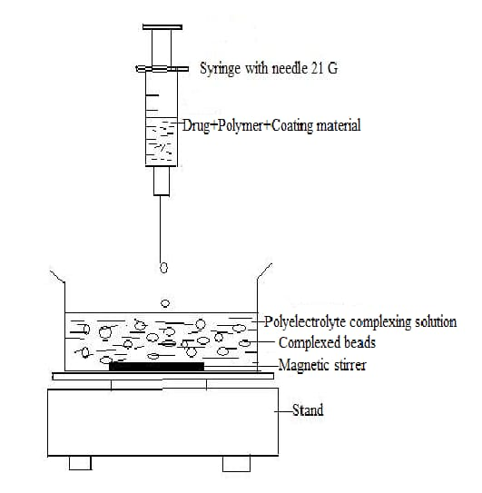
B) In the simultaneous method: the gelation of beads by calcium ions occurred simultaneously with the drug loading into the beads. The sodium alginate solution was introduced dropwise into CaCl2 solutions (concentration ranging from 1-3% w/v) which also contained a drug (concentration ranging from 2-3% w/v). After 1hr these beads were removed from the counter ion solution. The drug-loaded beads were washed and dried like blank beads (beads without drugs)^{[29]}
Fig No 6: Sodium Alginate Beads by Ionotropic Gelation method

Emulsion Gelation Method:
The oil-entrapped calcium alginate beads were created using the emulsion gelation technique. The polymer was dissolved in water while being stirred at a speed of 100 rpm. Selected oils (2.5 ml) were added to the polymer solution. The drug 50 mg was added to it. With gentle agitation of 37°C 0.5°C at room temperature, the homogenized or non-homogenized mixture was extruded into a 5% calcium chloride solution. The formed beads are allowed to stand for 5 min in the solution and then decanted, filtered, and finally dried overnight at room temperature.^{[30]}
Emulsion cross-linking method:
The medication was dissolved in the gelatin solution in this form, which has previously been heated at 400C for 1 hr. The solution was added drop by drop to liquid paraffin while at 350C, resulting in w/o emulsion, this mixture was roused at 1500 rpm for 10 minutes. Optional stirring should at 150C for 10 min. In 5 mL of aqueous glutaraldehyde-saturated toluene solution at 280C for 3 hours for cross-linking, the spherically shaped beads were washed three times with acetone and isopropyl alcohol, respectively, air-dried and discrete. Then formed beads with a 100 mL 10 mm glycine solution containing 0.1 percent w/v between 80 and 370C are preserved for 10 min to lump unreacted glutaraldehyde.^{[31]}
APPLICATIONS OF SODIUM ALGINATE BEADS:
Particulate spheres were developed using repeating units of substance that exhibit favorable biological behavior such as bioadhesion, and penetration-enhancing activities.
- Oral API Delivery:
The ability of particulate spheres that contain repeating units of substance to form films allows for formulation application as opposed to the solid dosage form.
- Gene Delivery:
Particulate spheres help in the gene carrier system. eg. Poliglusam, Gelatin, viral vectors, cationic lipoid system, polycations system & gene therapy along with DNA vector & also transport of insulin. It is helpful in vaccine delivery.^{[12]}
- Repeating units of substance-based API delivery systems:
Such as particulate, lipoid systems & gels have been demonstrated to have good bioadhesive nature & gain size easily when in contact with the nasal skin enhances the bioavailability & residence periods of the API to the nasal way. eg. Starch, Poliglusam, Gelatin 40.^{[13]}
- Cancer & Local API Delivery:
To deliver drug-like paclitaxel at the cancer site at therapeutically acceptable concentration, repeating units of substance films are designated.^{[14]} API mixtures, such as gelatin, PLGA, and poliglusam, have the potential to be used in controlled delivery in the oral cavity.
- Buccal API Delivery:
Because it has muco/bio attachment properties and can act as an absorption-increasing substance, a repeating unit of substance is a very good candidate for using a repeating unit of substance for the buccal target. Poliglusam, Sodium alginate. ^{[15,16]}

- Gastroscopy API Delivery:
Repeating units of substance granules having internal formulations formed by deacidifying, when added to acid or neutral components are found buoyant & support a sustained release of the API eg. Eudragit, methylcellulose + Carbopol, Gelatin.
- Skin API Delivery:
Repeating unit of substance has good film-producing properties. The API release from the structure is affected by the thickness & cross-linker of the matrix. eg. Poliglusam, Monoclonal antibodies, also known as targeting particulate spheres, are biologically immune particulate spheres.^{[17]} This type of sphere is used to get selective targeting to characteristic sites of the body part. Monoclonal Antibodies are specific molecules that bind to the characteristic part of the body through which absorption occurs. Viable adsorption & structural.
- Imaging:
The size of particulate spheres plays an important role in determining the imaging of specific areas using already labeled particulate spheres having radioactivity. The particulate spheres given via the IV route differ from the vein will usually become entrapped in the area of the lungs. ^{[18]}This phenomenon is specifically used for scintigraphic imaging of tumor masses in lungs using human serum albumin particulate spheres.
- Topical Porous Particulate spheres:
Micro sponges are porous particulate spheres having a size range of 5 to 300 µm. These sponges possess the capacity to entrap various APIs such as emollients, which can be used as a topical application.^{[19,20]}
- Physiological Application:
Release of high molecular weight substance over a longer period. Passive targeting toward leaky tumor vessels, active targeting of cancer cells, antigens, by I.V. route.
- Radio starts application:
It can be used to embolize various chemical and spleen cancers that are used for synovectomy of local chemotherapy, RA, imaging of the liver, red bone marrow, local chemotherapy, and even imaging of deep vein thrombosis. ^{[21]}
- Vaginal API Delivery:
Repeating unit of substance, modified by the introduction of thioglycolic acid to the primary amino groups of the repeating unit of substance is widely used for the treatment of mycotic infections of the genitourinary tract eg. Poliglusam, Gelatin, PLGA (3).^{[40,41]}
LITERATURE REVIEW
Kanchan Gupta et al., (2010) This review suggested to provide an overview of the mechanism of action of and clinical trial data for fesoterodine, and to discuss the present status of fesoterodine in the management of OAB. Overactive bladder (OAB) is a chronic condition affecting both men and women, with prevalence increasing with age. Antimuscarinics form the cornerstone of treatment of OAB. Fesoterodine, a nonselective muscarinic-receptor antagonist, was approved by the US Food and Drug Administration in late 2008 for once daily, oral administration in the treatment of OAB to relieve the symptoms of urinary urge incontinence, urgency, and frequency.
Linda Cardozo et al., (2010) This study defines Fesoterodine is an antimuscarinic for the treatment of overactive bladder, a syndrome of urgency, with or without urgency urinary incontinence (UUI), usually with increased daytime frequency and nocturia. Our objective was to develop predictive models to describe the dose-response of fesoterodine. A consistent dose response for fesoterodine was demonstrated for bladder diary endpoints in subjects with overactive bladder, a result that supports the greater efficacy seen with fesoterodine 8 mg in post hoc analyses of clinical trial data. The dose-response models can be used to predict outcomes for doses not studied or for patient subgroups underrepresented in clinical trials.
Shoaeb M. Syed et al., (2022) This review focuses on an attempt is made to develop novel multifunctional sustained-release in a capsule system by film coating Fesoterodine for the treatment of urinary incontinence (increased urinating frequency). Film-coated minitablets were satisfactorily developed in terms of various post-compression parameters like hardness, thickness, friability, weight variation, and content uniformity. IR and DSC studies revealed no significant drug-excipient interactions. HPMC phthalate-coated minitablets released in the buffer, and it was supposed that the drug releases in the intestine, which leads to better absorption and follows Korsmeyer-Peppas release kinetics.
Bilal Chughtai et al., (2015) This article discusses on the efficacy of long-acting fesoterodine on persistent lower urinary tract symptoms in men who have had previous surgical treatment for bladder outlet obstruction (BOO). Patients with persistent OAB symptoms after surgical treatment of BOO displayed possible reductions in the IPSS, IPSS irritative sub score, and mean number of nocturia events after 7 months of follow-up, as well as trends for an increased quality of life when treated with fesoterodine. Larger trials are needed to help characterize the utility of fesoterodine in the treatment of persistent lower urinary tract symptoms after surgical treatment of benign prostatic hyperplasia.
Shizuo Yamada et al., (2019) The present study aimed to characterize the muscarinic receptor binding of fesoterodine, 5-hydroxymethyl tolterodine (5-HMT), and tolterodine in the bladder and other tissues of rats after their oral, intravenous, or intravesical administration. Muscarinic receptors in tissues were measured by using [N-methyl-3 H] scopolamine methyl chloride. Orally administered fesoterodine exerted more selective and longer-lasting effects on muscarinic receptors in the bladder than in other tissues. Such selectivity may be attributed to the direct blockade of bladder muscarinic receptors by excreted urinary 5-HMT. Thus, fesoterodine may be efficacious in the treatment of patients with OAB.
Maria Tzefos et al., (2009) This article suggests pharmacologic, pharmacokinetic, efficacy, and safety data for fesoterodine and determines its role in the treatment of overactive bladder. Fesoterodine appears to be effective and generally safe for the treatment of overactive bladder. The efficacy and safety of fesoterodine in overactive bladder treatment seem to be at least similar to that of tolterodine. Although additional comparative trials are needed, based on available data, it does not appear that fesoterodine provides a substantial advantage over extended-release tolterodine in either efficacy or safety.
Maximiliano S. Sangoia et al., (2014) This review article identifies the dissolution test for fesoterodine low-dose extended-release tablets using a liquid chromatographic (LC) method equipped with a C18 monolithic column was developed and validated. The LC system was operated isocratically at a controlled temperature (40 1C) using a mobile phase of acetonitrile: methanol:0.03 M ammonium acetate (pH 3.8) (30:15:55, v/v/v), run at a flow rate of 1.5 mL/min and detected at 208 nm. The best dissolution conditions for this formulation were achieved using a USP apparatus 2 (paddle) at 100 rpm and 900 mL of phosphate buffer at pH 6.8 as the dissolution medium.
Kylie J Mansfield et al., (2009) This review article identifies that Muscarinic receptors have long been the target receptors for the treatment of patients with overactive bladder (OAB). These patients experience symptoms of urgency, urinary frequency, and nocturia, with or without urge incontinence (the involuntary leakage of urine associated with urge). Fesoterodine, a pro-drug, structurally and functionally related to tolterodine, is the newest agent developed for the treatment of OAB. Fesoterodine like, other antimuscarinic agents, is associated with adverse events such as dry mouth and constipation. However, the incidence of these adverse events is reduced compared, to the original muscarinic antagonist oxybutynin, due to the improved bladder selectivity of 5-HMT.

AIM AND OBJECTIVE

Aim: The aim of this project is to develop and evaluate microbeads with Fesoterodine fumarate as an active ingredient to facilitate sustained release action to treat Overactive Bladder Disease (OBD).

Objective:

- To prepare microbeads with good absorptive properties.
- To conduct in-vitro studies using Dissolution apparatus.
- Choosing and optimising the production process.
- To investigate the impact of polymer concentration on Fesoterodine and to find optimal polymer.
- To evaluate the prepared microbeads as per pharmacopeial standards.
- To Develop analytical methods and conduct drug-polymer interaction investigations (FTIR Spectral studies)

PLAN OF WORK

Literature survey on the various works carried out on this drug Fesoterodine Fumarate was reviewed. The work was planned in a sequential order to meet the objectives which is to develop and evaluate Micro beads of fesoterodine fumarate, with an aim to achieve a greater extent of bioavailability.

1. Selection of drug- depends on dosage, solubility, lipophilicity
2. Polymer selection- depends on drug-excipient compatibility, solubility
3. Preparation of micro beads for Fesoterodine Fumarate with polymers
4. Evaluation of sustained release micro beads
- Bead size measurement
- Swelling Index
- In-vitro dissolution studies
- Fourier Transform Infra-Red Spectroscopy
- Drug Content of the beads

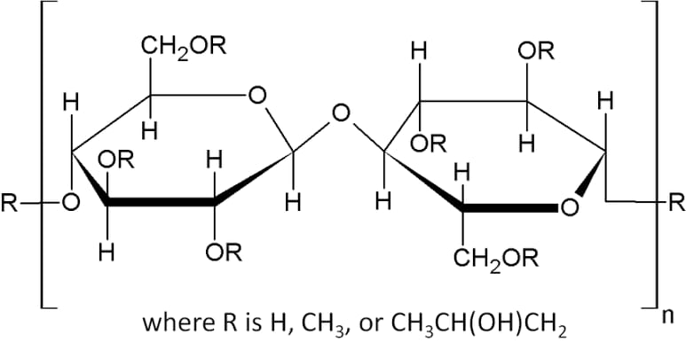

DRUG PROFILE

Name: Fesoterodine fumarate

Synonym: Fesoterodina

State: Solid

Description: Fesoterodine is an antimuscarinic agent used in the treatment of overactive bladder with symptoms of urge urinary incontinence, urgency, and frequency.
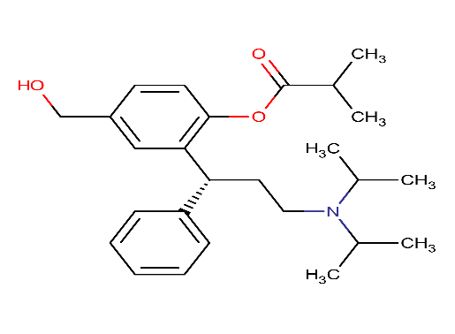
Chemical structure:

Molecular formula: C₂₆H₃₇NO₃
Molecular weight: Average: 411.5769, Monoisotopic: 411.277344055
Brand name: Toviaz
Category: Antimuscarinic
IUPAC Name: 2- [ (1R)-3- [bis (propan-2-yl) amino]-1-phenylpropyl]-4- (hydroxymethyl)phenyl 2-methylpropanoate
PHARMACOLOGY
Indication: Fesoterodine is indicated for the treatment of overactive bladder in adult patients with symptoms of urge urinary incontinence, urgency, and frequency. It is also indicated in the treatment of neurogenic detrusor overactivity in paediatric patients ≥6 years old weighing >25 kg.
Pharmacodynamics: In-vivo the Fesoteridine prodrug is broken down into its active metabolite, 5-hydroxymethyl tolterodine (5-HMT), by plasma esterases. The 5-hydroxymethyl metabolite, which exhibits antimuscarinic activity. Both urinary bladder contraction and salivation are mediated via cholinergic muscarinic receptors. Therefore, acting as a competitive muscarinic receptor antagonist, fesoterodine ultimately acts to decrease the detrusor pressure by its muscarinic antagonism, thereby decreasing bladder contraction and consequently, the urge to urinate.
Mechanism of action: Fesoterodine, once converted to its active metabolite, 5-hydroxymethyl tolterodine, acts as a competitive antagonist at muscarinic receptors. This results in the inhibition of bladder contraction, a decrease in detrusor pressure, and incomplete emptying of the bladder.

Metabolism: Metabolized by ubiquitous, nonspecific esterases to transform Fesoterodine into 5-HMT Extensive metabolism via CYP2D6 and CYP3A4 into inactive metabolites.
Absorption: tmax (5-HMT): 5 hours post-administration of Fesoterodine. AUC (0, ∞) = 49.5 ng·h/ ml Bioavailability, 5-HMT = 28%
Volume of distribution IV: 5-HMT: 169 L
Route of elimination: Renal: 70% of fesoterodine was recovered in urine as 5-HMT; 35% carboxy metabolite; 18% carboxy-N-desisopropyl metabolite, and 1% N-desisopropyl metabolite Faecal: 7% Hepatic: fesoterodine elimination via CYP2D6 and CYP3A4
Half-life: 7-8 hours for active metabolite 5-hydroxymethyl tolterodine
Experimental Properties of Fesoterodine fumarate:
Table No 2: Experimental properties of Fesoterodine Fumarate
PROPERTY | VALUE | SOURCE
Hydrogen Acceptor Count | 3 | CHEMAXON
Hydrogen Donor Count | 1 | CHEMAXON
Polar Surface Area | 49.77 Å² | CHEMAXON
Rotatable Bond Count | 11 | CHEMAXON
Refractivity | 124.08 m³·mol⁻¹ | CHEMAXON
Polarizability | 48.29 Å³ | CHEMAXON
Number of Rings | 2 | CHEMAXON
Bioavailability | 0 | CHEMAXON
Water Solubility | 0.00205mg/ml | ALOGPS
Ghose Filter | No | CHEMAXON
Veber’s Rule | No | CHEMAXON
MDDR-like Rule | No | CHEMAXON

Food Interactions: Take with or without food.
Drug Interactions:
Table No 3: Interaction with other drugs
DRUG | INTERACTION
Abacavir | Abacavir may decrease the excretion rate of Fesoterodine which could result in a higher serum level.
Aceclofenac | Aceclofenac may decrease the excretion rate of Fesoterodine which could result in a higher serum level.
Benznidazole | Fesoterodine may decrease the excretion rate of Benznidazole which could result in a higher serum level.
Warfarin | Fesoterodine may decrease the excretion rate of Warfarin which could result in a higher serum level.

EXCIPIENTS PROFILE
- CALCIUM CHLORIDE
Chemical structure:
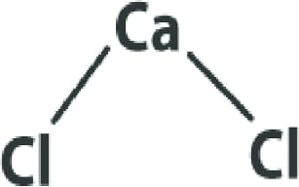

Synonym: Calcium; dichloride; dihydrate calcium chloride dihydrate, Cal Plus, Calcium chloride 2-hydrate
Molecular Formula: CaCl2.2H2O
Category: Firming agent

Applications in pharmaceutical formulations or technology: Calcium chloride dihydrate is a mineral salt typically used as buffering agent in pharmaceutical formulations. Beyond, calcium chloride dihydrate is used as a complexing builder, flavor enhancer and stabilizer for food and beverage.

Physical and Chemical Properties:

Molecular Weight: Anhydrous: 110.99; Dihydrate: 147.02

Colour: white

Nature: crystalline powder

Odour: odourless

Density: 2.15 g/cm3 (anhydrous)

Melting point :772 °C (anhydrous)

Boiling point:1935 °C (anhydrous)
pH: 4.5-8.5 (5% solution at 25°C)
Solubility: highly soluble in water, soluble in acetone, acetic acid and Insoluble in liquid NH3,
Stability and storage conditions: Stable under ordinary conditions of use and storage. Substance will pick up moisture from the air and go into solution if exposed in open containers. Store capped at room temperature. Protect from heat and incompatibles.
Incompatibilities: Calcium chloride (and its hydrates) are incompatible with boric acid, calcium oxide, bromine trifluoride, 2-furan, per carboxylic acid may produce explosive hydrogen gas on contact with zinc.

- SODIUM ALGINATE

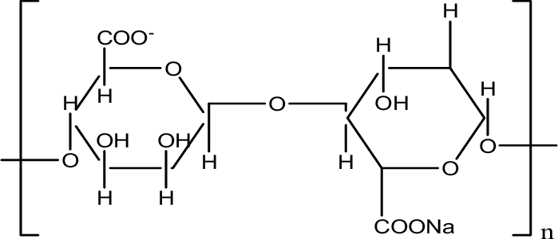
Chemical structure:

Non-Proprietary Names: BP - Sodium alginate
Ph. Eur- Natrii aligns
USPNF- Sodium alginate

Synonyms: Algin; alginic acid, sodium salt; kelcosol; keltone; protanal

Chemical name: Sodium;3,4,5,6-tetrahydroxyoxane-2-carboxylate

Molecular formula: C₆H₉NaO₇

Molecular weight: 216.12

Structural formula: Sodium alginate is a polymer consisting of two monomers, b-D- mannuronic acid, and a-L-guluronic acid.
Category: It is used as a stabilizing agent; suspending agent; tablet, capsule disintegrant; binder, viscosity modifier.

Application in pharmaceutical formulations:

Sodium alginate is used in variety of oral and pharmaceutical formulations. In tablet formulations, sodium alginate may be used as both a binder and disintegrant; it has also been used as a diluent in capsule formulations and also been used in the preparation of sustained release oral formulations, since it can delay the dissolution of a drug from tablets, capsules, and aqueous suspensions.
Recently, sodium alginate has been used for the aqueous microencapsulation of drugs, in contrast with the more conventional microencapsulation techniques which use organic solvent systems. It has also been used in the formation of nanoparticles.
The adhesiveness of hydrogels prepared from sodium alginate has been investigated and the drug release from oral mucosal adhesive tablets based in sodium alginate has been reported. Hydrogel systems containing alginates have also been investigated for delivery of proteins and peptides.
Therapeutically, sodium alginate has been used in the combination with an H2 receptor antagonist in the management of gastroesophageal reflux and as a hemostatic agent in surgical dressings. Alginate dressings, used to treat exuding wounds often contain significant amounts of sodium alginate as this improves the gelling properties.
Description: Sodium alginate occurs as an odorless, tasteless, and white to pale yellowish brown colored powder.
pH: Approximately 7.2 for a 1%w/v aqueous solution.
Solubility: Practically insoluble in ethanol, ether, and chloroform. Also, practically insoluble in other organic solvents and aqueous acidic solutions in which the pH is less than 3, but it is slowly soluble in water to form a viscous colloidal solution.
Viscosity (dynamic): Various grades of sodium alginates are commercially available that yield aqueous solutions of varying viscosity. Typically, a 1%w/v aqueous solution at 20º C will have a viscosity of 20-400 mPas (20- 400cp). Viscosity may vary depending upon concentration, pH, temperature, or the presence of metal ions, and in general above pH 10, viscosity decreases.

- HYDROXYPROPYL METHYLCELLULOSE
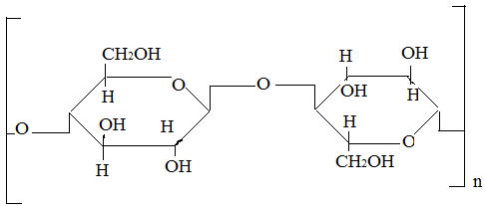
Chemical structure:

Synonyms: HPMC, Benecel MHPC, Methocel, Metolose.
Chemical name: Cellulose, 2-Hydroxypropyl methyl ether
Description: HPMC is an odorless and tasteless, white-coloured fibrous or granular powder
Category: Rate controlling polymer for sustained release. coating agent, suspending agent, tablet binder.
Applications: HPMC acts as a tablet binder, in film coating and as an extended-release tablet matrix.
It is used as suspending and thickening agent in topical formulations, particularly ophthalmic preparations as well as in cosmetic and food industry. With concentration of 2-5% w/w is used as binder.
HPMC powder ought to be kept in a very well closed container, in a very cool dry place.
It conflicts with some oxidizing agents and forms insoluble precipitates.

- TWEEN 80
Chemical structure:
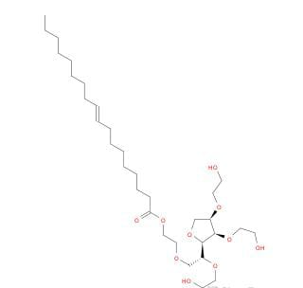

Synonyms: Polysorbate 80
Molecular formula: C₆₄H₁₂₄O₂₆
IUPAC Name: Polyoxyethylene (20) sorbitan monooleate

Category: Solubilizer, Anti-microbial, Preservative

Boiling point: > 100°C

Appearance: Amber colored liquid

Applications: used as a nonionic surfactant and emulsifier often used in pharmaceuticals, Foods
and cosmetics.

METHODOLOGY

ANALYTICAL METHOD DEVELOPMENT

Determination of absorption maxima
Take 100mg of pure drug was dissolved in 100ml of methanol (stock solution) 10 ml of above solution was taken and make up with 100ml by using pH 6.8 phosphate buffer. From this 10 ml was taken and make up with 100ml by using pH 6.8 phosphate buffer. UV spectrums was taken using Double beam UV/Visible spectrophotometer. The solution was scanned in the range of 200-400nm.

Procedure for establishing the Calibration Curve
100mg of pure drug was dissolved in 100ml of methanol (stock solution) 10ml of above solution was taken and makeup with 100ml by using pH 6.8 phosphate buffer. From this 10ml was taken and makeup with 100ml of pH 6.8 phosphate buffer. The above solution was subsequently diluted with buffer to obtain a series of dilutions containing 5,10,15,20 & 25µg/ml of pure drug per ml of solution.
The absorbance of the above dilutions was measured at 222nm by using UV-spectrophotometer taking 6.8 phosphate buffer as a blank and repeated.

PREPARATION OF MICROBEADS BY ION GELATION METHOD

Accurately weigh about 9% sodium alginate and egg albumin 10% of egg albumin
and kept aside, then it was dispersed in 100ml of distilled water by using a magnetic stirrer at 40ºc. Then after complete dispersion added and accurately 8mg of Fesoterodine fumarate then the stirring was continued until a complete and uniform dispersion was obtained. Then the calcium chloride solution was prepared by dispersing the 10mg of calcium chloride powder in 100ml of distilled water by heating at 40ºc. The resulting bubble-free dispersion was added manually dropwise with a 5ml syringe (22 gauze needle) into 100ml of(10%w/v) calcium chloride solution (CaCl₂) and stirred in a 250ml beaker. The gelation time of 15min was allowed to complete the curing reaction and produces spherical and rigid microbeads. The beads so prepared were collected by decantation and washed with water and dried in a hot air oven at 60 ºc for 2 hours. The process was applied to 7 different formulations by using varying proportions of egg albumin and sodium alginate (i.e., F2-F8)
as mentioned in Table no
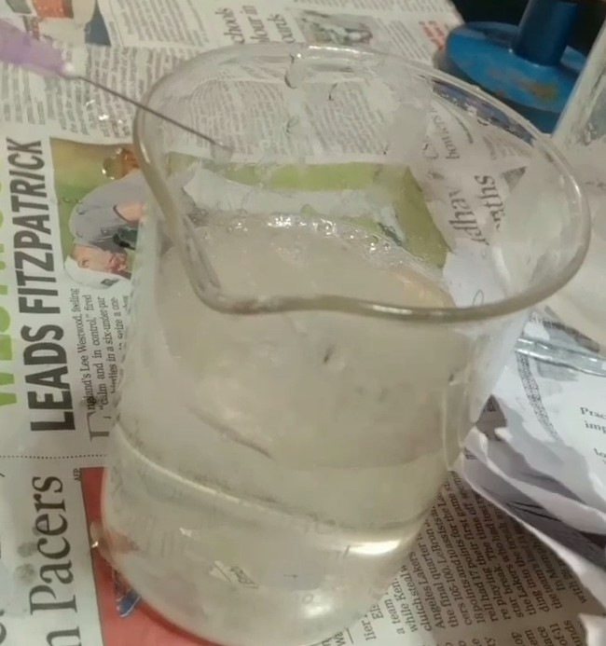
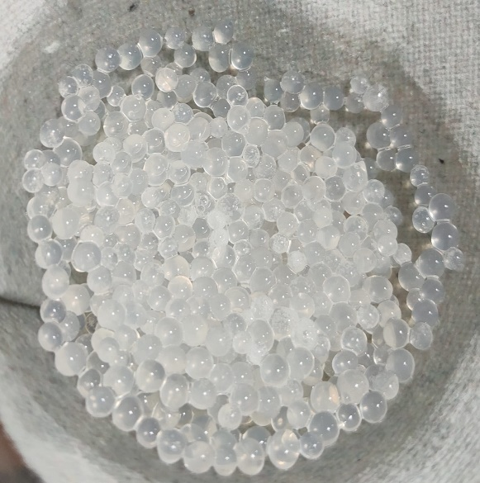

Fig No 7: Preparation of microbeads by using syringe needle
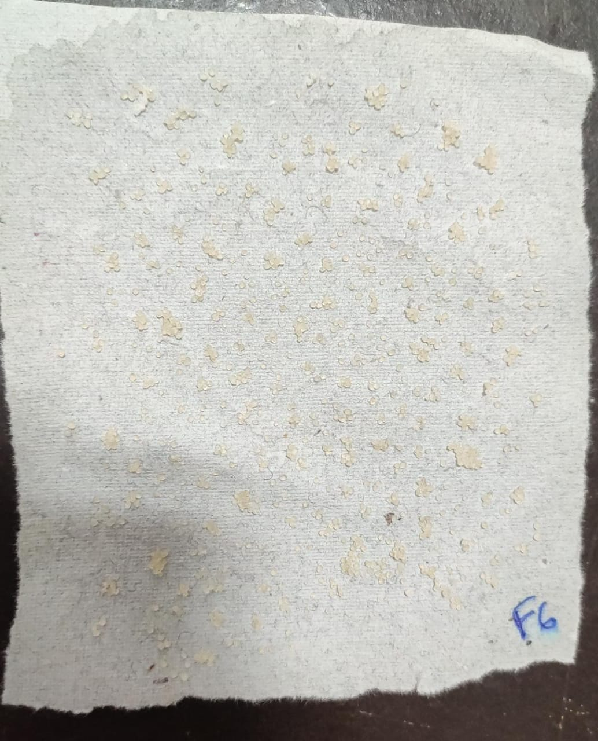

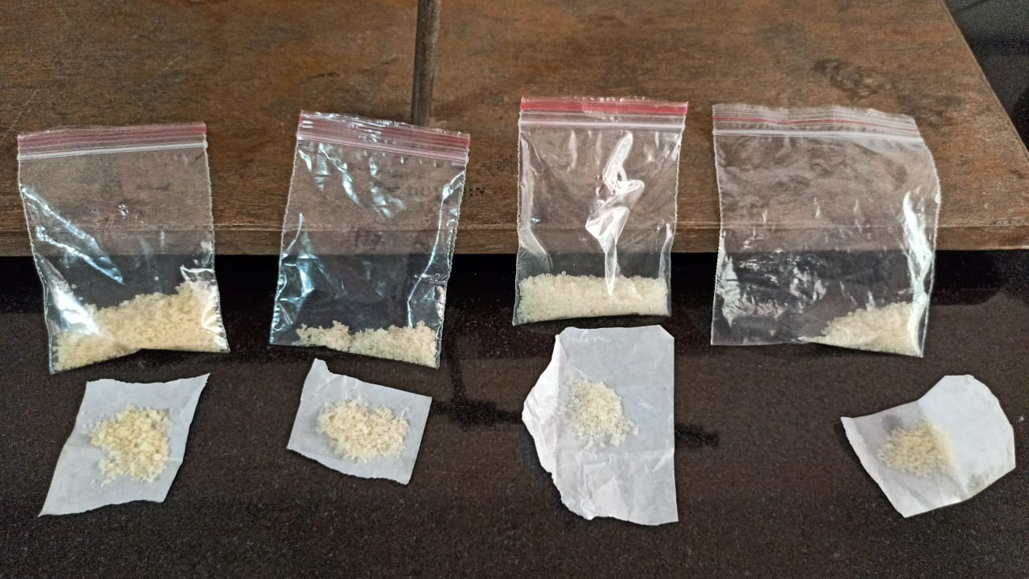

Fig No 8: Drying of microbeads and packing

Table No 4: Composition of different microbeads containing Fesoterodine Fumarate

S. No | Formulation Code | API (Fesoterodine Fumarate) mg | Egg Albumin | Sodium Alginate (% w/v) | HPMC (mg) | Tween 80 (ml) | Water | Calcium chloride (% w/v)
1 | F1 | 8 | 10 | 1 | 2 | 0.4 | q.s | 10
2 | F2 | 8 | 20 | 3 | 4 | 0 | q.s | 10
3 | F3 | 8 | 10 | 5 | 2 | 0.4 | q. s | 10
4 | F4 | 8 | 20 | 7 | 4 | 0 | q. s | 10
5 | F5 | 8 | 10 | 9 | 2 | 0.4 | q. s | 10
6 | F6 | 8 | 20 | 11 | 4 | 0 | q. s | 10
7 | F7 | 8 | 10 | 13 | 2 | 0.4 | q. s | 10
8 | F8 | 8 | 20 | 15 | 4 | 0 | q. s | 10

The materials/ chemical ingredients and instruments utilized in this study are mentioned below

Table No 5: List of materials /ingredients used

S. No | Materials/ Ingredients | Supplier | Uses
1 | Fesoterodine Fumarate |  | Active Pharmaceutical Ingredient
2 | Egg Albumin | MOLYCHEM, Mumbai | Natural polymer
3 | Sodium Alginate | MOLYCHEM, Mumbai | Natural polymer
4 | Hydroxy Propyl Methyl Cellulose | MOLYCHEM, Mumbai | Polymer used for sustain release
5 | Tween 80 | MOLYCHEM, Mumbai | Synthetic polymer
6 | Calcium Chloride | MOLYCHEM, Mumbai | Solvent

Table No 6: List of Equipment used

S. No | Name of the Equipment | Model/Company
1 | UV Visible Spectrophotometer | Shimadzu
2 | Dissolution Apparatus | Lab India
3 | Magnetic stirrer | Remi’s

EVALUATION
- Fourier Transform Infra-Red Spectroscopy:
The compatibility between pure drug and polymer was detected by FT-IR spectra obtained. Samples were reduced to powder and analyzed as KBr pellets by employing a Fourier transform-infrared (FTIR) spectroscope (Perkin Elmer Spectrum RX I, USA). The pellet was placed within the sample holder. Spectral scanning was taken within the wavelength region between 4000 and 400 cm−1 at a resolution of 4 cm−1 with a scan speed of 1 cm/s.
- Surface Morphology Analysis by Scanning Electron Microscopy (SEM):
Drug-coated beads were mounted on a brass stub using double-sided adhesive tape and sputtered with a tiny layer of gold (3–5 nm) under vacuum in an ion sputter for 75 s and at 20 kV to make them electrically conductive, and their morphology was observed using a scanning electron microscope (ZEISS EVO 40, Japan).
- Bead Size Measurement:
The particle size of 100 dried beads from every batch was measured by optical microscopic technique for average particle size using an optical microscope (Olympus). The ocular micrometer was formerly calibrated by a stage micrometer.
4) Drug content of the beads:
Beads (20 mg) in 20 mL of PB (pH 6.8) in amber-colored vials were sonicated for 15 min and mixed at 750 rpm for 4 hr. in the dark for complete extraction of the drug. The dispersion was then centrifuged at 5000 rpm for 15 min at 15°C. The drug content of the supernatant of each sample was then measured using a validated UV method at 232 nm.
- Loose surface crystal study:
The drug-loaded microcapsules were evaluated for loose surface crystal study to calculate the excess amount of drug present on the surface of microcapsules. For that, 100 mg of microcapsule were shaken in 20 ml of pH 7.4 phosphate buffer for 5 min and filtered through a 0.45 µm membrane filter. The amount of drug present in the filtrate was determined spectrophotometrically, which yields the total drug content.
- Percent moisture loss:
The microbeads were evaluated for percentage moisture loss, which gives an idea about the hydrophilic nature. The weighed amount of microbeads (W1) was initially kept in a desiccator containing calcium chloride at 37° for 24 h. The final weight (W2) was noted when no further change in the weight of the sample was observed. Finally, the percent moisture content was determined by the following formula.
Percent moisture loss= (W1-W2/W1) ×100 -------
- Differential scanning calorimetry (DSC): DSC was performed for the pure drug, physical mixture of drug with polymers, and optimized microbeads in DSC apparatus (Shimadzu DSC 60, Tokyo, Japan). Samples were heated from 30 to 300°C at the heating rate of 10°C/min in the nitrogen atmosphere (flow rate, 20 ml/min).
- Swelling index:
The swelling index was determined by keeping the prepared microbeads in a pH 7.4 phosphate buffer solution for 12 h. After overnight wetting, these swollen microbeads were collected and their weight was noted. From the weight of the microbeads before and after wetting, the swelling index was calculated by the following formula.
Sw= (Wt-Wo/Wo) ×100
where Sw=percent swelling of microbeads,
Wt=weight of the microbeads at time t,
Wo=initial weight of the microbeads
- Determination of DEE:
100 mg of beads were taken and crushed using a pestle and mortar. The crushed powders of drug-containing beads were placed in a very 250 ml volumetric flask and volume was made up to 250 ml by phosphate buffer, pH 7.4, and kept for 24 h with infrequently shaking at 37 ± 0.50 C. After the specified time mixture was stirred at 500 rpm for 20 min using a magnetic stirrer (Remi Motors, India). The polymer debris fashioned after the disintegration of the bead was removed by filtering through Whatman® filter paper (No. 40). The drug content within the filtrate was determined using a UV–vis spectrophotometer (Shimadzu, Japan) at 233 nm against an acceptable blank. The DEE (%) of these prepared beads was calculated by the subsequent formula.
DEE (%) =actual drug content in beads/Theoretical drug content in beads×100
- In Vitro Drug Release Studies:
The release of the drug from numerous beads was tested using dissolution equipment USP (Campbell Electronics, India). The baskets were enclosed with 100-mesh nylon cloth to stop the seepage of the beads. The dissolution rates were measured at 37 ± 10C under 50 rpm speed. Accurately weighed quantities of beads containing Vildagliptin equivalent to 100 mg were added to 900 ml of 0.1 N HCl (pH 1.2). The test was carried out for 2 h and then continued in phosphate buffer (pH 7.4) for the next 8 h. 5 ml of aliquots was collected at regular time intervals, and therefore the same quantity of fresh dissolution medium was replaced into the dissolution vessel to keep the sink condition throughout the experiment. The collected aliquots were filtered and suitably diluted to determine the absorbance using a UV– vis spectrophotometer (Shimadzu, Japan) at 233 nm against a suitable blank.
- Stability study:
The stability studies of the optimized microcapsules were carried out as per the ICH guidelines. These microbeads were suitably packed in high-density plastic bottles and stored at 40°C/75% RH for 3 months in the stability chamber. These microbeads were evaluated for physicochemical properties, drug content, and in vitro drug release at specified periods (0, 1, 2, and 3 months) to assess their stability.

RESULTS and DISCUSSION

In this study, an effort has been made to prepare and evaluate microbeads of Fesoterodine Fumarate.
Preformulation study:

S.No | Parameter | Observation
1 | Color | White
2 | Odour | Odourless
3 | Appearance | Pale white
4 | Solubility | Water, methanol, 6.8 p H Phosphate buffer
Table No 7: Organoleptic properties
Standard calibration curve of Fesoterodine Fumarate:
Standard stock solution: The standard stock solution was prepared by dissolving 100mg of the drug in 100ml of phosphate buffer 6.8
Calibration curve of Fesoterodine Fumarate in phosphate buffer pH 6.8:
Absorbance was taken at 222nm for the above solution to attain 5,10,15,20,25 µg/ml dilutions. Absorbance for these concentrations was taken and the linearity plot at 222nm with absorbance is shown in Fig no

Table No 8: Calibration curve of Fesoterodine Fumarate in pH 6.8 phosphate buffer

S.No | Concentration (µg/ml) | Absorbance
1 | 0 | 0
2 | 5 | 0.181
3 | 10 | 0.362
4 | 15 | 0.543
5 | 20 | 0.712
6 | 25 | 0.867

Fig No 9 : Standard Graph of Fesoterodine Fumarate

Table No 9: Evaluation parameters
Formulation Code | Drug Content | Swelling Index | Size Distribution
F1 | 93 | 32.2 | 110
F2 | 91 | 43 | 123
F3 | 92 | 58 | 136
F4 | 98 | 94 | 83
F5 | 95 | 68 | 136
F6 | 89 | 82 | 140
F7 | 97 | 79 | 128
F8 | 94 | 73 | 115

DRUG-EXCIPIENT COMPATIBILITY BY FTIR
Drug and polymers identified by FTIR spectroscopy. The FTIR spectrum given below shows the peaks of the drug, polymer.
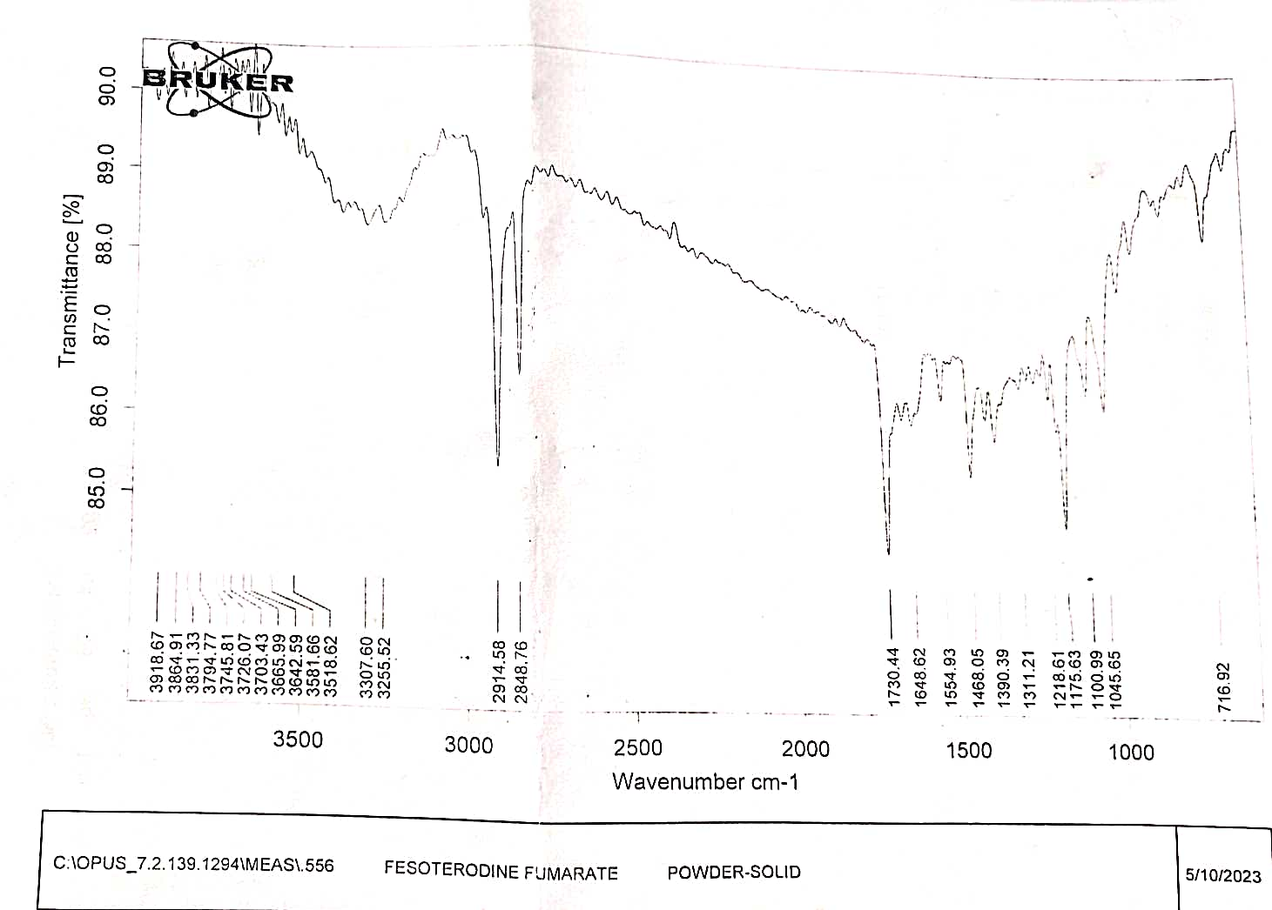

Fig No 10: FTIR spectrum of Fesoterodine Fumarate

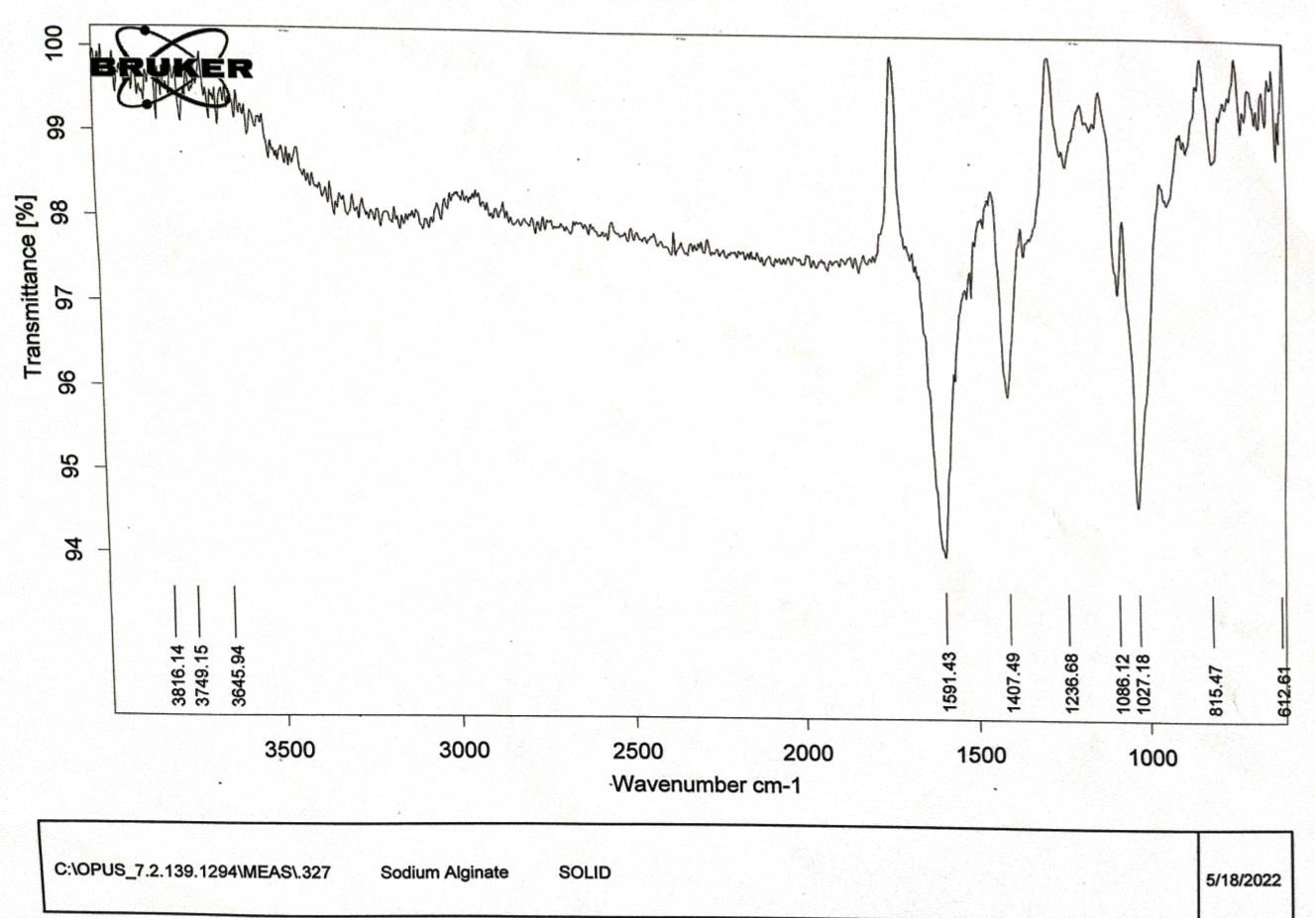

Fig No 11: FTIR spectrum of Sodium Alginate
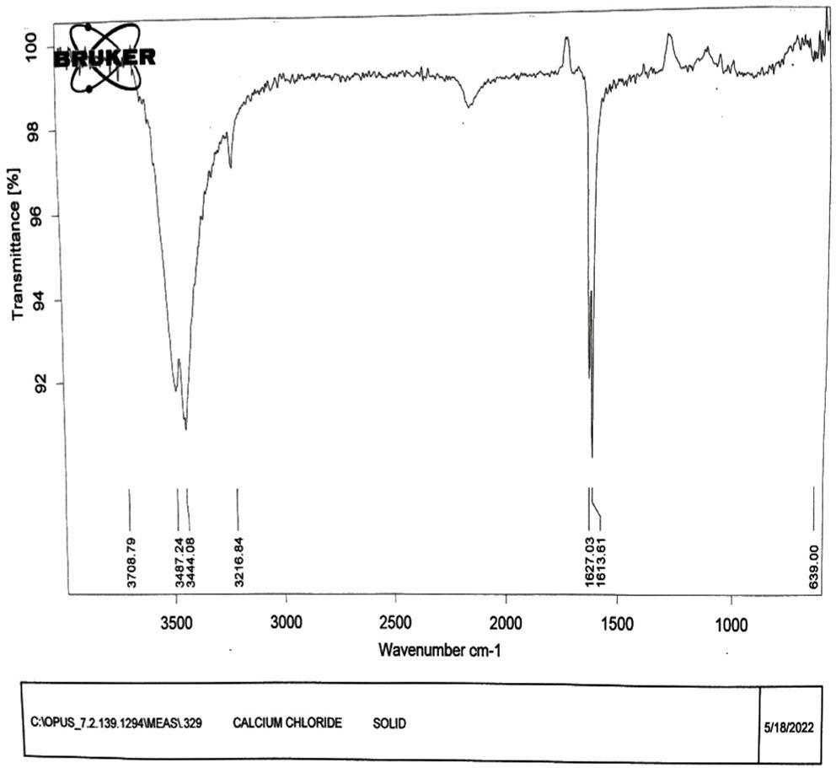

Fig No 12: FTIR spectrum of Calcium Chloride
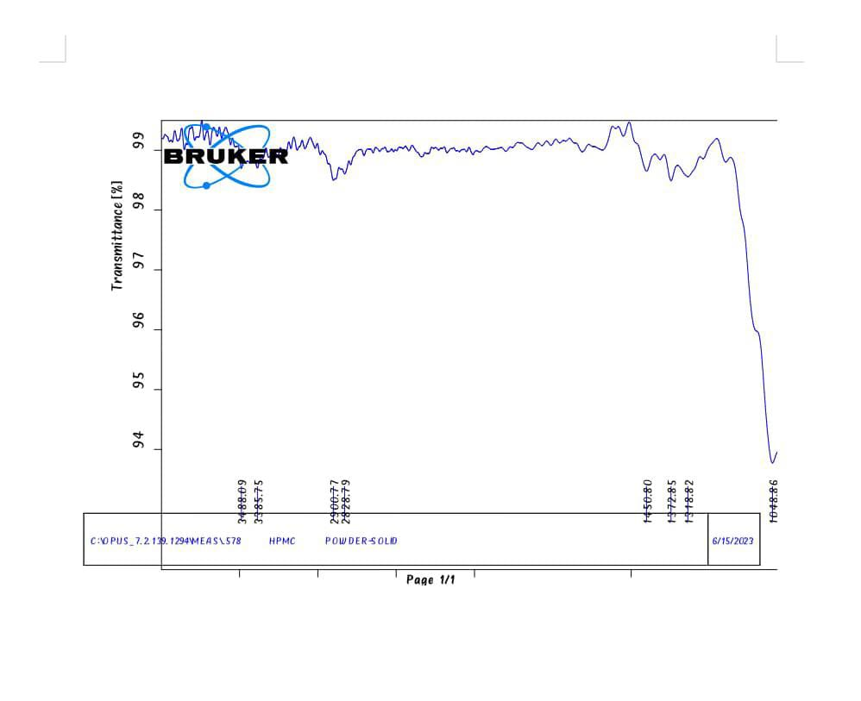

Fig No 12: FTIR spectrum of HPMC

Fig No 13: FTIR spectrum of HPMC
Drug Excipient interactions are effectively analyzed by Fourier transform infrared (FTIR) spectroscopy (Shimadzu). FTIR spectra of pure drug, Fesoterodine Fumarate, Sodium Alginate, Calcium Chloride, and HPMC are observed.

Table No 10: FTIR spectra of Fesoterodine Fumarate pure drug display principal bands at a wave number as follows.

Functional Groups | Mode of Vibration | Wave number
OH | Stretching | 2992.30
C=C | Stretching | 1659.53
C=O | Stretching | 1754.59  1722.79
FTIR spectra of optimized formulation show bands for specific functional groups in Fesoterodine Fumarate. All peaks are almost matching with functional group peaks of pure drugs. so, the drug is compatible with the polymer.

POST FORMULATION STUDIES OF FESOTERODINE FUMARATE
In-vitro Dissolution Studies
The assessment was done by using pH 6.8 phosphate buffer as a dissolution medium in the USP basket apparatus with a maintained temperature of 37±0.2ºc. A sample of 5ml was drawn at sequential time intervals and the same amount of freshly prepared phosphate buffer 6.8 was replaced. A liquid of (5ml) of the dissolution medium was withdrawn at 1,2,3,4,5,6,7 and 8hr intervals and the same quantity was replaced with a fresh medium. Samples were assayed using a U.V spectrophotometer at 222nm and the cumulative drug release percentage was calculated.

Table No 11: In-vitro dissolution studies of different formulations (F1-F4)

Time (hrs) | F1 | F2 | F3 | F4
0 | 0 | 0 | 0 | 0
1 | 17 | 12 | 14 | 16
2 | 26 | 22 | 28 | 29
3 | 37 | 34 | 39 | 37
4 | 48 | 41 | 53 | 52
5 | 59 | 54 | 69 | 62
6 | 71 | 64 | 77 | 79
7 | 88 | 79 | 87 | 87
8 | 93 | 91 | 94 | 98

Fig No 14: In-vitro Drug release (F1-F4)

Table No 12: In-vitro dissolution studies of different formulations (F5-F8)

Time (hrs) | F5 | F6 | F7 | F8
0 | 0 | 0 | 0 | 0
1 | 13 | 15 | 14 | 11
2 | 18 | 24 | 25 | 19
3 | 26 | 36 | 31 | 28
4 | 39 | 44 | 45 | 37
5 | 54 | 55 | 57 | 49
6 | 69 | 72 | 77 | 63
7 | 76 | 89 | 84 | 75
8 | 88 | 95 | 90 | 82

Fig No 15: In-vitro Drug release (F5-F8)

CONCLUSION

A new sustained-release system of drug-entrapped calcium alginate beads was formulated by an ion gelation method. The beads were designed by different excipients like HPMC, egg albumin, tween-80, and sodium alginate along with the drug. Different evaluation tests are performed like FTIR studies, swelling index, drug content, bead size measurement, and in-vitro dissolution studies. All the results obtained from the tests are correlated with the limits and were found to be within the range. It’s morphological and release characteristics were studied. The beads were easy to prepare and the mean diameter of beads increased with the effect of the amount of sodium alginate and HPMC. From the proposed study, the F4 formulation was found to have drug content, swelling index and bead size, and high dissolution rate. The total drug release from F4 formulation in p^{H} 6.8 phosphate buffer (dissolution medium) was found to be 98% drug release. Among different Formulations, F4 has shown a high dissolution rate effect. The beads showed excellent sustaining properties as compared to the conventional beads. Thus, the ion gelation technique appears to be a useful tool for the development of multi-particulate systems even for a water-soluble drug.

REFERENCES:

- Leon Lachman, Herbert A, Lieberman, Jospeh L.kanig. The Theory and Practice of industrial pharmacy 1990. Third edition: p 430 -456.
- Robinson, JR. Lee, HLV Controlled drug delivery: Fundamentals and applications. Second edition: p 373-374.
- D.M.Brahmankar, Sunil B Jaiswal. Biopharmaceutics and pharmacokinetics, A treatise: 1995. First edition: p 335-337.
- Bidgar N.N., Pawar R.H., Chakole, R. D., Burade K.B., Charde M.S An Overview: Sustained-Release Sodium Alginate Beads June 2021 Vol.:21, Issue:3
- Maya Sharma, Kajal Jain, Suresh Kumar Dev, P. K. Choudhury Formulation and Evaluation of Sodium Alginate Beads by Emulsion Gelation Method Asian Journal of Pharmaceutics • Jan-Mar 2017 (Suppl) • 11 (1) | S101
- Suryakanta Swain1 *, Aurobinda Behera, Sarwar Beg1, Chinam N. Patra, Subash C. Dinda2, Jammula Sruti1, and Muddana E. B. Rao1, "Modified Alginate Beads for Mucoadhesive Drug Delivery System: An Updated Review of Patents", Recent Patents on Drug Delivery & Formulation 2012, 6, 259-277.
- Khan, Ismail, & Gani, "Recent Development in Sustained-Release Beads" International Journal of Research in Pharmaceutical Sciences, 27 Jan 2020.
- Suryakanta Swain1 *, Aurobinda Behera, Sarwar Beg1, Chinam N. Patra, Subash C. Dinda2, Jammula Sruti1, and Muddana E. B. Rao1, "Modified Alginate Beads for Mucoadhesive Drug Delivery System: An Updated Review of Patents", Recent Patents on Drug Delivery & Formulation 2012, 6, 259-277.
- Engyel M, Kállai-Szabó N, Antal V, Laki AJ, Antal I. Microparticles, particulate spheres, and microcapsules for advanced drug delivery. Sci Pharm. 2019; 87 (3)
- DAS MK, AHMED AB, SAHA D. Particulate spheres a Drug Delivery System Review. Int J Curr Pharm Res.2019; 34–41.
- Khan, Ismail, & Gani, "Recent Development in Sustained-Release Beads" International Journal of Research in Pharmaceutical Sciences, 27 Jan 2020.
- Rakesh Pahwa1 *, Neeta1, Seema1, Rajeev Garg2 and Sanju Nanda "Formulation and Evaluation of Floating Multiparticulate Drug Delivery System of Glipizide"Pelagia Research Library Der Pharmacia Sinica, 2011, 2 (5):110-120
- Valluru Ravi *, T.M. Pramod Kumar1 and N. Rama Rao "Investigation of Ghatti Gum as a Carrier to develop Polymeric Blend Beads of Galantamine Hydrobromide" International Journal of ChemTech Research CODEN (USA): IJCRGG ISSN: 0974-4290 Vol.9, No.03 pp 482-490, 2016
- Venkateshwar Reddy A *, Sairam Maduri, "Formulation and evaluation of low cost sustained release floating alginate beads", Venkateshwar Reddy A and Sairam Maduri (2012) Int. J. Res. Pharm. Sci., 3 (3), 398-403.
- Shilpa. A., Agrawal S. S., Ray. A. R., Controlled delivery of drugs from alginate matrix. Journal of Macromolecular science part C-Polymer Reviews. 43 (2) (2003) 187-221.15)
- Shilpa. A., Agrawal S. S., Ray. A. R., Controlled delivery of drugs from alginate matrix. Journal of Macromolecular science part C-Polymer Reviews. 43 (2) (2003) 187-221.
- Kulkarni A.R., Soppimath K.S., Aralaguppi M.I., Aminabhavi T.M., Rudzinski W.E., Preparation of crosslinked sodium alginate microparticles using glutaraldehyde in methanol. Drug Dev. Ind. Pharm.26 (10) (2000) 1121–1124.19)
- Shu X.Z., Zhu K.J., The release behavior of brilliant blue from calcium-alginate gel beads coated by chitosan: the preparation method effect. Eur. J. Pharm. Biopharm. 53 (2) (2002) 193–201.
- Gonzalez-Rodríguez M.L., Holgado M.A., Sanchez-Lafuente C., Rabasco A.M., Fini A., Alginate/chitosan particulate systems for sodium diclofenac release. Int. J. Pharm. 232 (1–2) (2002) 225–234.
- Shilpa. A., Agrawal S. S., Ray. A. R., Controlled delivery of drugs from alginate matrix. Journal of Macromolecular science part C-Polymer Reviews. 43 (2) (2003) 187-221.
- BASU, S.K.; RAJENDRAN, A. Studies in the development of neteglinide loaded calcium alginate and chitosan-coated calcium alginate beads. Chem. Pharm. Bull., v.56, p.1077-1084, 2008.
- Miléna Lengyel 1, Nikolett Kállai-Szabó1, Vince Antal 1, András József Laki 2and István Antal 1, * Microparticles, Microspheres, and Microcapsules for Advanced Drug Delivery, Sci. Pharm. 2019.
- Deepak Sharma *, Sanjay Kumar Sharma, Manish Jaimini, and Amit Kumar A REVIEW ON MULTIPARTICULATE FLOATING DRUG DELIVERY SYSTEM INTERNATIONAL JOURNAL OF PHARMACEUTICAL, CHEMICAL AND BIOLOGICAL SCIENCES IJPCBS 2014, 4 (1), 201-207.
- Kwok K.K., Groves M.J., Burgess D.J., Production of 5–15 µm diameter alginate-polylysine microcapsules by air-atomization technique. Pharm. Res. 8 (1991) 341–344.
- Bodmeier R., Chen H.G., Paeratakul O., A novel approach to the oral delivery of micro-or nanoparticles. Pharm. Res. 6 (5) (1989) 413–417.
- Shilpa. A., Agrawal S. S., Ray. A. R., Controlled delivery of drugs from alginate matrix. Journal of Macromolecular science part C Polymer Reviews. 43 (2) (2003) 187-221.
- Gombotz W.R., Wee S.F., Protein release from alginate matrices, Adv. Drug Deliv. Rev. 31 (1–2) (1998) 267–285.)
- Sanchita Mandal, S. Senthil Kumar, Balakrishnam Krishnamoorthy, Sanat Kumar Basu * "Development and evaluation of calcium alginate beads prepared by sequential and simultaneous methods" Brazilian Journal of Pharmaceutical Sciences vol. 46, n. 4, out./dez., 2010.
- Khan, Prebeg, & Kurjaković, 1999; Khan ", Sridhar, & Srinatha, 2010, Recent Development in Sustained Release Beads" Mon, 27 Jan 2020 in International Journal of Research in Pharmaceutical Sciences.
- Suryakanta Swain1 *, Aurobinda Behera1, Sarwar Beg1, Chinam N. Patra1, Subash C. Dinda2, Jammula Sruti1, and Muddana E. B. Rao1, "Modified Alginate Beads for Mucoadhesive Drug Delivery System: An Updated Review of Patents", Recent Patents on Drug Delivery & Formulation 2012, 6, 259-277.
- Abiya Sara Cherian * Boby Johns G, Praveen Raj R, Daisy P.A, Jeny Samuel, "Formulation and Evaluation of FSM-Alginate Beads of Vildagliptin" Journal of Drug Delivery & Therapeutics. 2019; 9 (4-A):246-251.
- Amit Kumar Nayak1 and Dilipkumar Pal 2 *, "Ionotropically-gelled mucoadhesive beads for oral metformin HCl delivery: Formulation, optimization, and antidiabetic evaluation", Journal of Scientific & Industrial Research Vol. 72, January 2013.
- Sanchita Mandal, S. Senthil Kumar, Balakrishnam Krishnamoorthy, Sanat Kumar Basu * "Development and evaluation of calcium alginate beads prepared by sequential and simultaneous methods" Brazilian Journal of Pharmaceutical Sciences vol. 46, n. 4, out./dez., 2010.
- Behzad Mokhtare1, Meltem Cetin1 *, Rukiye Sevinc Ozakar1 and Hatice Bayrakceken 1Department of Pharm In vitro and in vivo evaluation of alginate and alginate-chitosan beads containing metformin hydrochloride Trop J Pharm Res, February 2017; 16 (2): 287.
- Thulasi V Menon *, C.I.Sajeeth, "Formulation And Evaluation Of Sustained Release Sodium Alginate Microbeads Of Carvedilol," Thulasi V Menon et al/Int.J.PharmTech Res.2013,5 (2)
- Kajal Ghosal *, Sarbani Dey Ray, "Alginate/hydrophobic HPMC (60M) particulate systems: New matrix for site-specific and controlled drug delivery" Brazilian Journal of Pharmaceutical Sciences vol. 47, n. 4, oct./dec., 2011.
- S. SWAIN *, A. BEHERA, S. C. DINDA1, C. N. PATRA, SRUTI JAMMULA, S. BEG AND M. E. B. RAO "Formulation Design, Optimization and Pharmacodynamic Evaluation of Sustained Release Mucoadhesive Microcapsules of Venlafaxine HCl" Indian Journal of Pharmaceutical Sciences July-August 2014.
- Abiya Sara Cherian * Boby Johns G, Praveen Raj R, Daisy P.A, Jeny Samuel, "Formulation and Evaluation of FSM-Alginate Beads of Vildagliptin" Journal of Drug Delivery & Therapeutics. 2019; 9 (4-A):246-251.
- Gregory E.H., Lloyd, G., Tillman, M.G.F., Rahul, C., Mehta, C.L.T. Multiparticulate formulation. US0027780A1 (2003).
- Virani T pharmaceutical application of particulate spheres s an approach for the treatment of various diseases International journal of pharmaceutical science and research science 2017; 8 (8):3252–60.
- Kamrun Nahar1 *, Md Kamal Hossain1 * + and Tanveer Ahmed Khan2, "Alginate and Its Versatile Application in Drug Delivery" Kamrun Nahar et al/J. Pharm. Sci. & Res. Vol. 9 (5), 2017, 606-61788.
- L. N. Pettingill, A. K. Wise, M. S. Geaney, and R. K. Shep-herd, "Enhanced auditory neuron survival following cell-based BDNF treatment in the deaf guinea pig," PLoS ONE, vol. 6, no.4, Article ID e18733, 2011.94.

